**PROJECT PART 2**

**Big Data Analytics Cumali Bereket s211060**

**Applied Informatics and Mathematics Faculties Warsaw University of Life Sciences**

**Project Title: Real Estate Agency Management System**

**Project Manager: Cumali Bereket**

# BACKGROUND PROBLEM

**I live in a small town called Adıyaman in southeast part of Turkey, which is around 200 km far from Syrian border and between 4 big cities. The population of my hometown is 632.148, the surface area of city 1.679km2. The city has some really popular touristic places. And that places gets visitors from all over the world. City growing quite fast, there are many new buildings and apartments build by government and private companies. Real Estate market has a good business potential in Adıyaman. But the market and system are not big enough. The city needs a better and more useful Real Estate Management system. That’s why I want to invest in that business.**

**In 2 part of my project I want to create a website of real estate management system.**

# THE GOALS

**Scope of the project:**

**Scope of our project is creating a real estate agency management system for our real estate agency office. That’s why I want to create a website of our real estate agency office.**

**Within the project scope:**

**Within our project scope we will start by creating our real estate agency management system website. Our goal for finishing the project scope within 2 months. And provide it to our customers for using it.**

**The main objective of this project is to build a Real Estate Agency Office that is adequate and integrated with a good information system. The Office will be rented as 30 m2 in the city center.**

**The office will be in the center of city, the location of office will be well known and for the office we should buy office components (The new furniture and computers etc.).**

**The project will be carried out within 6 months (from 01 January 2023 – 30 July 2023).**

**As we planned for our 1 part of project we want to create a website within 2 months.**

# OBJECTIVES

**Some of the objectives that will be accomplished in this project are listed below:**

**Looking for right location and office for renting.**

**Manage all official permissions related to open a Real Estate Agency Office.**

**Purchase all necessary furniture’s at office furniture provider companies.**

**Buy all the computer and network equipment at a computer store.**

**Buy all necessary devices for office from technical store.**

**Finding a Software Development company for creating website of Real estate agency office.**

**J. Finding an advertisement provider company for making advertisements in a city.**

**Recruiting office personnel: Accountants, Sales Specialists.**

**K. Conduct training of workers and employees.**

# STAKEHOLDERS

**The following is a list of who will be involved in this project:**

**The people who needs properties: houses, accommodation, land, office, apartments, rooms (for rent and buy): The customers who will need Real Estate Agency Office.**

**The people who want to sell or rent properties: lands, houses, apartments, rooms etc.**

**Software company: Related to the design and construction of web based Real Estate Agency information system.**

|  |  |  |
| --- | --- | --- |
| **Stakeholder** | **Role** | **Responsibilities** |
| **Project Manager** | **Manager** | **Looking for the right location to rent an office.** |
| **Project Manager** | **Manager** | **Manage all official permissions related to open a Real Estate Agency Office.** |
| **Project Manager** | **Manager** | **Purchase all necessary furniture’s at office furniture provider companies.** |
| **Project Manager** | **Manager** | **Buy all the computer and network equipment at a computer store** |
| **Project Manager** | **Manager** | **Buy all necessary devices for office from technical store.** |
| **Project Manager** | **Manager** | **Finding a Software Development company for creating website of Real estate agency office** |
| **Project Manager** | **Manager** | **Finding an advertisement provider company for making advertisements in a city.** |
| **Recruitment team** | **Manager** | **Recruiting office personnel: Accountants, Sales Specialists.** |
| **Project Manager** | **Manager** | **Conduct training of workers and employees.** |
| **Project Manager** | **Manager** | **Finding an advertisement provider company for making advertisements in a city.** |
| **Project Manager** | **Manager** | **Opening the Real Estate Agency Office.** |

# SUCCESS CRITERIA

**Here are a few success criteria for launching this project:**

**The project was completed right on schedule, and the costs incurred were still within the set budget.**

**There are no problems related to renting office and getting official permission.**

**Recruitment of Real Estate Office workers is carried out on time and get the right candidates.**

**The information system built can be used properly and according to Real Estate Agency needs.**

**All equipment purchased according to the budget and from trusted vendors.**

**The opening and inauguration of the Real Estate office went correctly.**

# PROJECT MAIN TASKS

|  |  |  |
| --- | --- | --- |
| **Task name** | **Duration** | **Responsibility** |
| **Looking for the right location to rent an office.** | **1 Week** | **Cumali Bereket (Entrepreneur)** |
| **Manage all official permissions related to open a Real Estate Agency Office.** | **2 Weeks** | **Cumali Bereket (Entrepreneur)** |
| **Purchase all necessary furniture’s at office furniture provider companies.** | **1 Week** | **Cumali Bereket (Entrepreneur)** |
| **Buy all the computer and network equipment at a computer store** | **2 Weeks** | **Cumali Bereket (Entrepreneur)** |
| **Buy all necessary devices for office from technical store.** | **1 Week** | **Cumali Bereket (Entrepreneur)** |
| **Finding a Software Development company for creating website of Real estate agency office** | **1 Month** | **Cumali Bereket (Entrepreneur)** |
| **Finding an advertisement provider company for making advertisements in a city** | **1 Week** | **Cumali Bereket (Entrepreneur)** |
| **Recruiting office personnel: Accountants, Sales Specialists.** | **1 Week** | **Cumali Bereket (Entrepreneur)** |
| **Conduct training of workers and employees.** | **3 Months** | **Cumali Bereket (Entrepreneur)** |
| **Opening the Real Estate Agency Office** | **1 Day** | **Cumali Bereket (Entrepreneur)** |

# MILESTONES

**The following table displays the milestones from the active project. The project will be started on the 01/01/2023.**

|  |  |  |
| --- | --- | --- |
| **Task name** | **Deadline** | **Deadline** |
| **Looking for the right location to rent an office.** | **2 Weeks** | **15/01/2023** |
| **Manage all official permissions related to open a Real Estate Agency Office.** | **2 Weeks** | **30/01/2023** |
| **Purchase all necessary furniture’s at office furniture provider companies.** | **1 Week** | **07/03/2023** |
| **Buy all the computer and network equipment at a computer store** | **2 Weeks** | **21/03/2023** |
| **Buy all necessary devices for office from technical store.** | **1 Week** | **30/03/2023** |
| **Finding a Software Development company for creating website of Real estate agency office** | **1 Month** | **30/04/2023** |
| **Finding an advertisement provider company for making advertisements in a city** | **1 Week** | **07/05/2023** |
| **Recruiting office personnel: Accountants, Sales Specialists.** | **2 Week** | **21/05/2023** |
| **Conduct training of workers and employees.** | **2 Months and 1 Week** | **29/07/2023** |
| **Opening the Real Estate Agency Office** | **1 Day** | **30/07/2023** |

# PROJECT BUDGET

**To open Real Estate Agency Office in Adıyaman Turkey, my budget for all the costs is around 175000 -200000 Turkish liras totally.**

|  |  |
| --- | --- |
| **Task name** | **Cost** |
| **Looking for the right location to rent an office.** | **5000 tl** |
| **Manage all official permissions related to open a Real Estate Agency Office.** | **8000 tl** |
| **Purchase all necessary furniture’s at office furniture provider companies.** | **25000 tl** |
| **Buy all the computer and network equipment at a computer store** | **30000 tl** |
| **Buy all necessary devices for office from technical store.** | **20000 tl** |
| **Finding a Software Development company for creating website of Real estate agency office** | **15000 tl** |
| **Finding an advertisement provider company for making advertisements in a city** | **10000 tl** |
| **Recruiting office personnel: Accountants, Sales Specialists.** | **40000 tl** |
| **Conduct training of workers and employees.** | **20000 tl** |
| **Opening the Real Estate Agency Office** | **2000 tl** |
| **Total Spending** | **175000 tl** |

# CONSTRAINTS

**Sometimes in carrying out a project there are several obstacles or obstacles that can occur, as well as how the solutions will be offered:**

|  |  |
| --- | --- |
| **What Could Go Wrong** | **Solutions** |
| **The location of the Real Estate Agency Office is less strategic** | **Before Renting an Office, having enough knowledge about the city. Do a lot of research on the location , environment then when we rent an office for Real Estate Agency, it will be easy for customers and property owners to reach and easy to find.** |
| **Hard to Find Experienced Employees** | **Make agreements with recruitments companies and find suitable employees.** |
| **Office Components (Furniture’s, computers,**  **Networking devices etc.) cannot be purchased according to the schedule** | **We should order early, make agreements and make plans before ordering all stuff, get enough information about purchasing, select multiple vendors at once to avoid shortages of needed items.** |
| **Expenditure According to Our Budget** | **First of all, we should know all needs and components about our project. Pay attention to all the needs of the project. We shouldn’t buy anything that is not useful and we should be careful about our expenses.** |
| **Employees Doesn’t understand the new about our Real Estate Agency information system.** | **Provide employee training on information systems, city, location, environment that will be useful at the**  **Real Estate Agency.** |

# THREAT / RISK

# The following is a list of some potential project management risks and strategies for addressing them.

# Scope Creep Risk Uncontrolled and unapproved alterations to the project scope may result in the cost of new features, products, or functionalities.

# During the project, clinic construction may be modified in a number of ways, including adding rooms to buildings, adding tools, changing information systems, etc. However, in order for the project to be completed on time, all modifications must be under control and not exceed the budget.

# Scope creep is closely associated with budget creep. Changes in the scope of the project may, without a doubt, have a negative effect on the project's financial results, but other reasons may also be involved.

# Overly optimistic cost projections have the potential to result in a budget overrun, just like when we underestimate the amount of time or outside resources required to complete the project.

# Sometimes, there are unexpected shifts in labor costs or material costs for building the clinic. These will be discussed later. The project budget almost always suffers as a result of poor planning and communication.

# How to deal with it:

# The project manager does not have complete control over every budget modification. Before submitting a completed budget, conduct extensive research and hold off until the project plan and timeline are complete.

# Poor planning can put the project at risk because successful project management relies heavily on the timing of the project. Drafting a document, which is now frequently a digital one, that specifies the project duration and organizational resources required for each activity is part of the scheduling process.

# The project schedule must be accessible to each team member. Because its purpose is to provide the team with important information, it needs to be comprehensive and easy to understand. Project scheduling consists of eight phases, and although it may take some time, utilizing the appropriate tools will assist in avoiding numerous risks that would otherwise affect the project.

# How to deal with it:

# It takes careful preparation to create a project timeline. If the project is planned well, many tools for the project roadmap may be helpful in keeping things on track. We might find that a simple shared calendar works well, depending on the project's size and complexity.

# DETAILED DESCRIPTION OF THE ACTIVITIES

**STEP II – PROJECT**

# USER STORY MAP - MVP RELEASE I

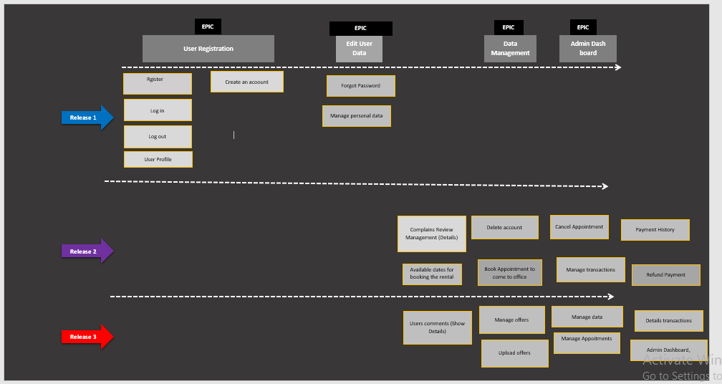

# MOSCOW ANALYSIS:

**Moscow analysis from the functions.**

|  |  |  |  |
| --- | --- | --- | --- |
| **No** | **Function** | **Point** | **Priority** |
| **1** | **Log in** | **4** | **Should** |
| **2** | **Log out** | **3** | **Should** |
| **3** | **User Registration** | **4** | **Should** |
| **4** | **User Profile** | **5** | **Must** |
| **5** | **Edit User Data** | **5** | **Must** |
| **6** | **Deactivate Account** | **3** | **Should** |
| **7** | **Available dates for booking the rental places** | **4** | **Should** |
| **8** | **Book Appointment to come to office** | **4** | **Should** |
| **9** | **Cancel Appointment** | **4** | **Should** |
| **10** | **Admin Dashboard** | **5** | **Must** |
| **11** | **Data Management (Add, Show List, Edit, Delete, Show Details)** | **5** | **Should** |
| **12** | **Tools Management (Add, Show List, Edit, Delete, Show Details)** | **4** | **Should** |
| **13** | **Offers and Post management** | **5** | **Must** |
| **14** | **Transaction History management** | **3** | **Should** |
| **15** | **Details transactions** | **3** | **Should** |
| **16** | **Payment History** | **3** | **Could** |
| **17** | **Refund Payment** | **4** | **Could** |
| **18** | **Forgot Password** | **4** | **Could** |
| **19** | **Complains Review Management ( Show List, Edit, Delete, Show Details)** | **5** | **Must** |
| **20** | **Post Complains and Reviews** | **3** | **Could** |
| **21** | **Users comments ( add comment, delete comment, manage comment.)** | **3** | **Could** |

# PRODCUT BACKLOG:

**STORY POINTS: 1-5 (1-Opcjonal -- 5-Must)**

# CARD GENERATOR:

**Here is the card generator view for the main features of the project.**

|  |  |  |  |
| --- | --- | --- | --- |
| **Id** | **1** |  |  |
|  | **Log in** |  |  |
|  | **User story** |  | **Importance** |
|  | ***I would like to access the application as a customer to view the available appointment dates and property offers (rental properties, properties for sale).*** |  | **4** |
|  |  |  |  |
|  | **How to test** |  | **Estimate** |
|  | ***When I enter my user name and password and click the Log in button on the real estate agency website's start page, I should already be logged in to my account.*** |  | **24** |
|  |  |  |  |
|  |  |  |  |
|  |  |  |  |
| **Id** | **2** |  |  |
|  | **Log out** |  |  |
|  | **User story** |  | **Importance** |
|  | ***I want to be able to log out of the system as a customer so that other people can't see my private information.*** |  | **4** |
|  |  |  |  |
|  | **How to test** |  | **Estimate** |
|  | ***Since I am logged in to the system, pressing the Log out button should take me to the index page and log me out of the session.*** |  | **24** |
|  |  |  |  |
| **Id** | **3** |  |  |
|  | **User Registration** |  |  |
|  | **User story** |  | **Importance** |
|  | ***I want to register it online from my phone as a customer, which saves me from having to visit a real estate agency.*** |  | **4** |
|  |  |  |  |
|  | **How to test** |  | **Estimate** |
|  | ***Customers will be directed to the registration page, where they will press the "Register" button after filling out the entire form. The data will be saved to the database, and the user will be taken to the login page.*** |  | **24** |
|  |  |  |  |
| **Id** | **4** |  |  |
|  | **User Profile** |  |  |
|  | **User story** |  | **Importance** |
|  | ***Users have access to their personal information and photos..*** |  | **5** |
|  |  |  |  |
|  | **How to test** |  | **Estimate** |
|  | ***Given the page with the profile picture and all of the user information.*** |  | **32** |
|  |  |  |  |
| **Id** | **5** |  |  |
|  | **Edit User Data** |  |  |
|  | **User story** |  | **Importance** |
|  | ***The user can change their profile picture, email address, phone number, and other personal information..*** |  | **5** |
|  |  |  |  |
|  | **How to test** |  | **Estimate** |
|  | ***Given a page with user data displayed on it and an editable form, the user can edit the data and submit new data.*** |  | **32** |
|  |  |  |  |
| **Id** | **6** |  |  |
|  | **Deactivate Account** |  |  |
|  | **User story** |  | **Importance** |
|  | ***Users can disable their accounts.*** |  | **4** |
|  |  |  |  |
|  | **How to test** |  | **Estimate** |
|  | ***When the users clicks the deactivate account button then they can see the options for deactivating account.*** |  | **24** |
|  |  |  |  |
| **Id** | **7** |  |  |
|  | **Forgot Password** |  |  |
|  | **User story** |  | **Importance** |
|  | ***Passwords can be reset by users.*** |  | **4** |
|  |  |  |  |
|  | **How to test** |  | **Estimate** |
|  | ***When users clicks the on the Forgot Password button then can click and reset their passwords .*** |  | **24** |

# JIRA BACKLOGS

# https://cumalibereket.atlassian.net/jira/software/projects/CUM/boards/1/backlog

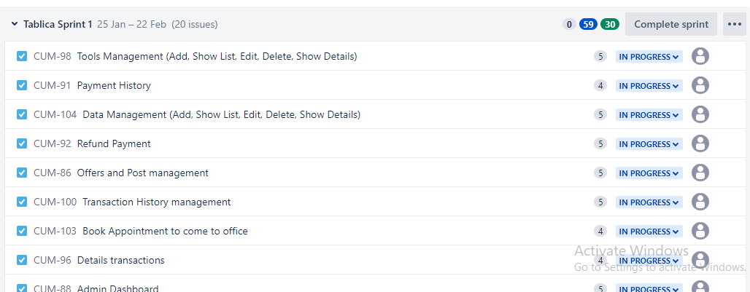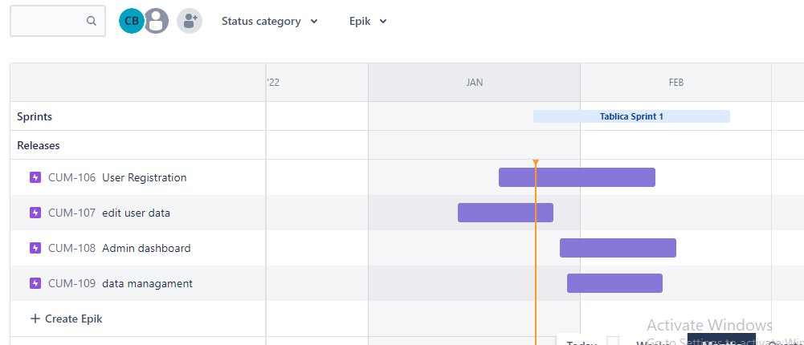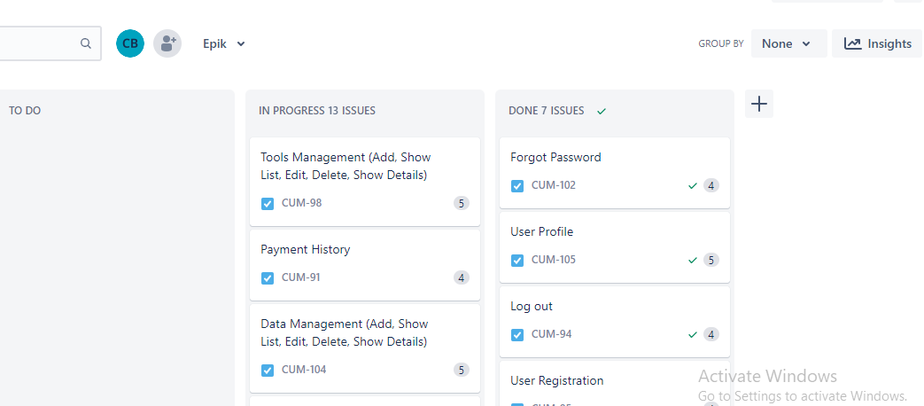

**Burnup report**

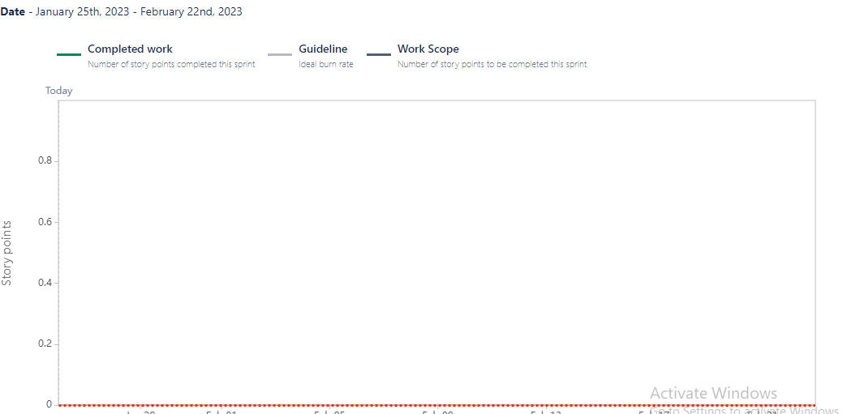

**Sprint burn down chart**

